**Step 3:** Adding Selenium references or drivers in C# project.  
  
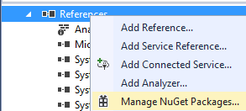

1. Firstly, open solution explorer.
2. Then expand the project.
3. Right click on references and select ‘**Manage Nuget Packages’** option.

Then you can see the following screen:  
  
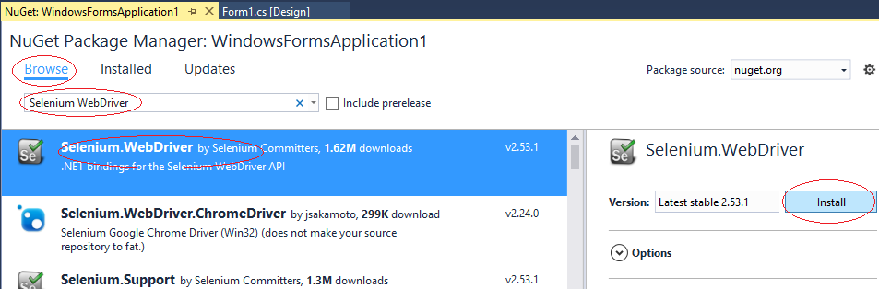

Then follow steps as in the following image:

1. Type Selenium WebDrive
2. Click Browse
3. Select Selenium.webdriver
4. Click install.

After successfully installing you can see the following screen.  
  
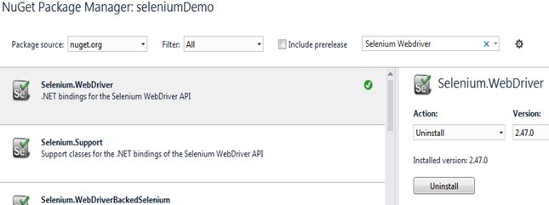  
  
And in references.  
  
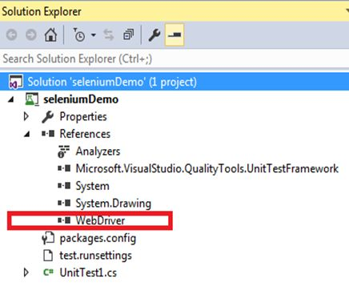

using OpenQA.Selenium;

using OpenQA.Selenium.Chrome;

using OpenQA.Selenium.Firefox;

using OpenQA.Selenium.IE;

Now open the file UnitTest1.cs to start actual coding to integrate selenium webdriver in our C# application.  
  
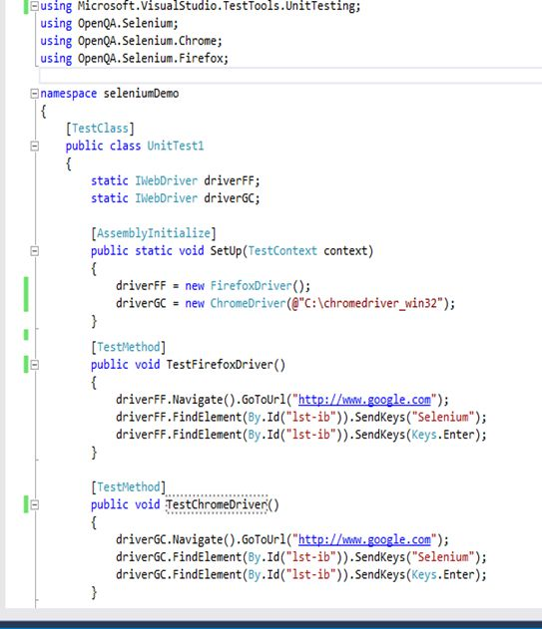  
  
Now we go step by step:  
  
**Add below references:**

1. **using** OpenQA.Selenium;
2. **using** OpenQA.Selenium.Chrome;
3. **using** OpenQA.Selenium.Firefox;

The above references can provide all classes and properties required to integrate the selenium webdrivers.  
  
One more important thing is that download chromedriver on your local machine   
  
Please download it from the [url](https://sites.google.com/a/chromium.org/chromedriver/downloads).  
  
By this way you need to download webdriver as per your expected browser.  
  
Now we will run the test cases